Dictionary Loop and String Formatting

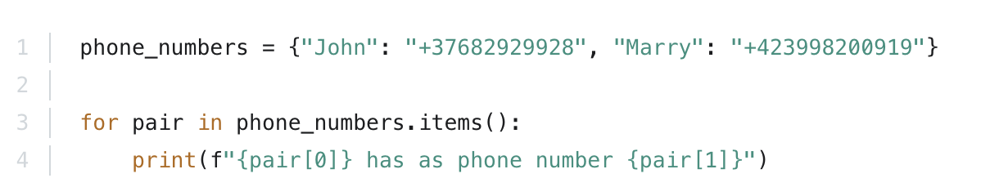
Here is an example that combines a dictionary loop with string formatting. The loop iterates over the dictionary and it generates and prints out a string in each iteration:
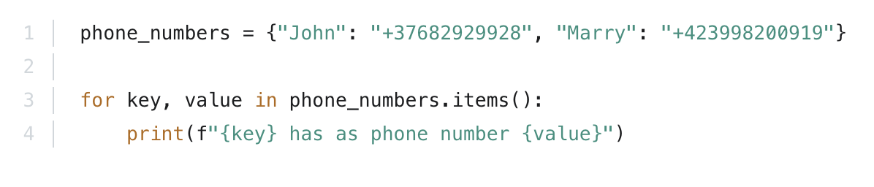
And here is a better way to achieve the same results by iterating over keys and values:
In both cases, the output is:
John has as phone number +37682929928
Marry has as phone number +423998200919

